WEB 2 – Team 1

Team members:

* Mikael Ivanov 3707717
* Mihail Lepadatu 3793435
* Marcello Cardillo 3774201

# Document history

|  |  |  |
| --- | --- | --- |
| Name | Description | Date |
| Mikael | Added wireframes | 9/03/20 |
| Marcello | Added description, scope, deliverables | 10/03/20 |
| Marcello | Added sequence diagrams, added class relationships | 12/03/20 |
| Marcello | Added Sitemap for Tasks | 21/03/20 |
| Marcello | Added Sitemap for Calendar, week 5 deliverables | 22/03/20 |
| Mikael | Sitemap, Wireframes Updated | 22/03/20 |
| Marcello | Minor edits to deliverables, added non deliverables  Added images of final look. | 10/04/20 |
| Marcello | Updated final look with tasks styling  Added project functionalities for all modules (since they are all the same)  And added dashboard to project functionalities. | 11/04/20 |

Contents

Document history 1

1. Project Description 3

2. Project Scope 3

3. Deliverables 3

4. Project functionalities And Sitemap 5

5. Wireframes 7

6. Final Look 12

Dashboard 12

Employees 12

Dashboard 12

Departments 13

Adding components popup 13

Tasks 14

Calendar 14

7. Sequence Diagram and Class Relationships 15

a. Class Relationships 16

## Project Description

|  |  |
| --- | --- |
|  | The goal is to create a front-end web application that will enable us to manage multiple tasks that are assigned to departments. The employees will also be assigned to a task registered within the application. The goal is to make it simple to use and straight forward while including multiple functionalities. |

## Project Scope

|  |  |
| --- | --- |
|  | The project will include a dashboard which will hold three different lists.  Each list will hold different entities (Departments, Employees, Tasks) each with their own details that will be displayed on click.  Clicking on any of the entities in any list should display details of such, and buttons with multiple functionalities:   * Adding a task to a department. * Adding an employee to a task. * Removing a task from a department. * Removing an employee from a task.   Tasks should store which Department they belong to, which employees are working on it, and when it has to be completed.  Departments should store which employees are working there.  Employees should store to which department they belong to. |

## Deliverables

|  |  |  |  |  |  |  |  |  |  |  |  |  |  |  |  |  |  |  |  |  |  |  |
| --- | --- | --- | --- | --- | --- | --- | --- | --- | --- | --- | --- | --- | --- | --- | --- | --- | --- | --- | --- | --- | --- | --- |
|  | |  |  |  | | --- | --- | --- | | Deliverable | Due | Completed? | | Setup Development Environment  Setup GIT Environment with three branches | Week 1 | Checkmark | | Create a module for the 3 different entities  Display a list of strings by populating a grid | Week 2 | Checkmark | | Display details for each unique entity in the list  Implement CRUD functionalities for each entity | Week 3 | Checkmark | | Implement a Factory for each unique entity  Change modules to store information of the other modules with their respective attributes mentioned in the Project Scope.  Display the Dashboard with the three different lists. | Week 4 | Checkmark | | Change components to enable users to search for their own respective component  Install ng Bootstrap  Style the view of components  Create a routing module and add a nav bar to your app  Calendar module for your application that tracks tasks | Week 5 | Checkmark | | Change components to import from API while maintaining CRUD functionalities.  Added search bar | Week 6 | Checkmark | |

Non-Deliverables (will expand as we add features)

* *Error messages when connecting to API*
* *Sorting for components*
* *Adding tasks functionalities to calendar*

## Project functionalities And Sitemap

#### Modules

6

5

4

3

2

1

1. The initial container holds a list of all the available tasks. Currently supplied by mock tasks and an internal database.
2. All delete buttons are functional and will remove the task if clicked until the application is reset.
3. The second container holds a button to add a task to the list. You only need to insert the id as the task description can be edited.
4. The third container holds the details of the task clicked. As you can see the selected task from the list is also highlighted in blue.
5. The assigned department is only shown if the task is assigned to a department. The button to assign to a department is at the bottom of the container.
6. The assigned employees show in a list with their first and last names displayed. The assign employee button is on the bottom of the container.

#### A picture containing boat, sitting, water, empty Description automatically generatedCalendar

3

2

1

4

5

1. The name of the month we are currently in will be displayed as well as the current year in the title.
2. The buttons in the middle filter the calendar view for month/week/day. Automatically chooses the day and week we are currently in.
3. The buttons on the right will change the month from current month to previous and next respectively. Today will bring you back to the month we are currently in.
4. The day we are currently in is highlighted. The day this screenshot was captured would be March 22, 2020.
5. The tasks will display as text boxes on the calendar.

#### Dashboard

1. A screenshot of a cell phone

   Description automatically generatedDisplays lists of each modules “top” task/department or employee.

#### Dashboard

## Wireframes

|  |  |  |  |  |  |  |  |  |
| --- | --- | --- | --- | --- | --- | --- | --- | --- |
|  |  |  |  |  |  |  |  |  |

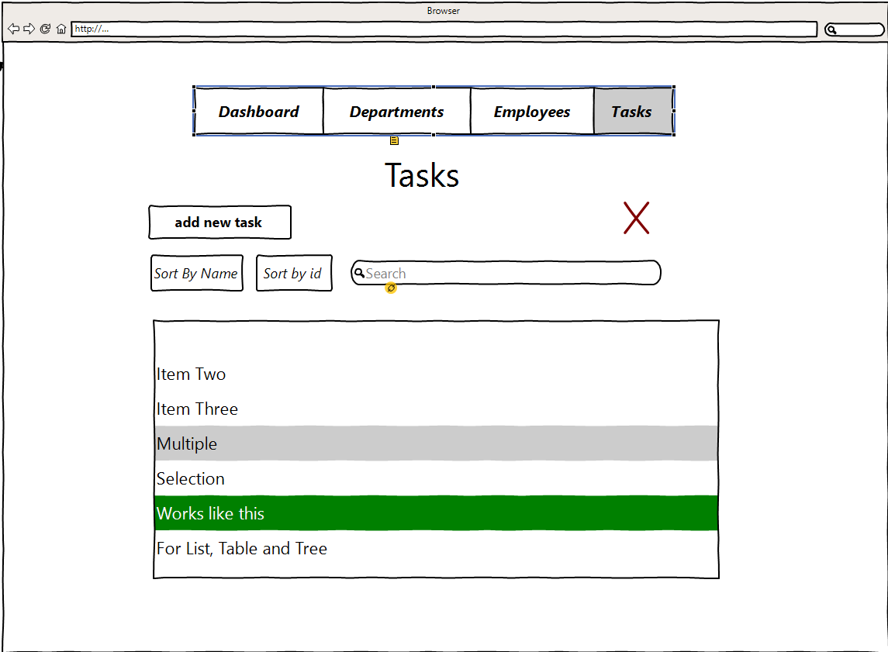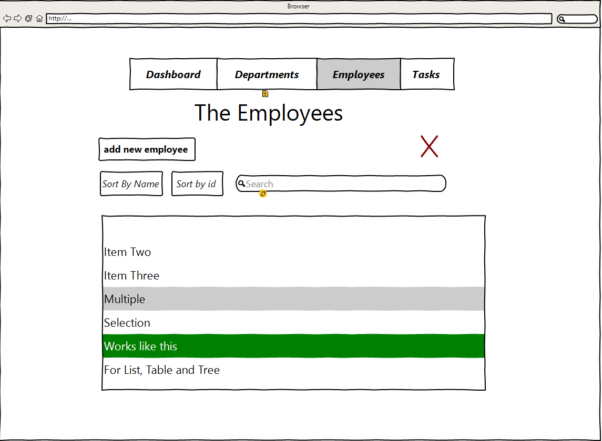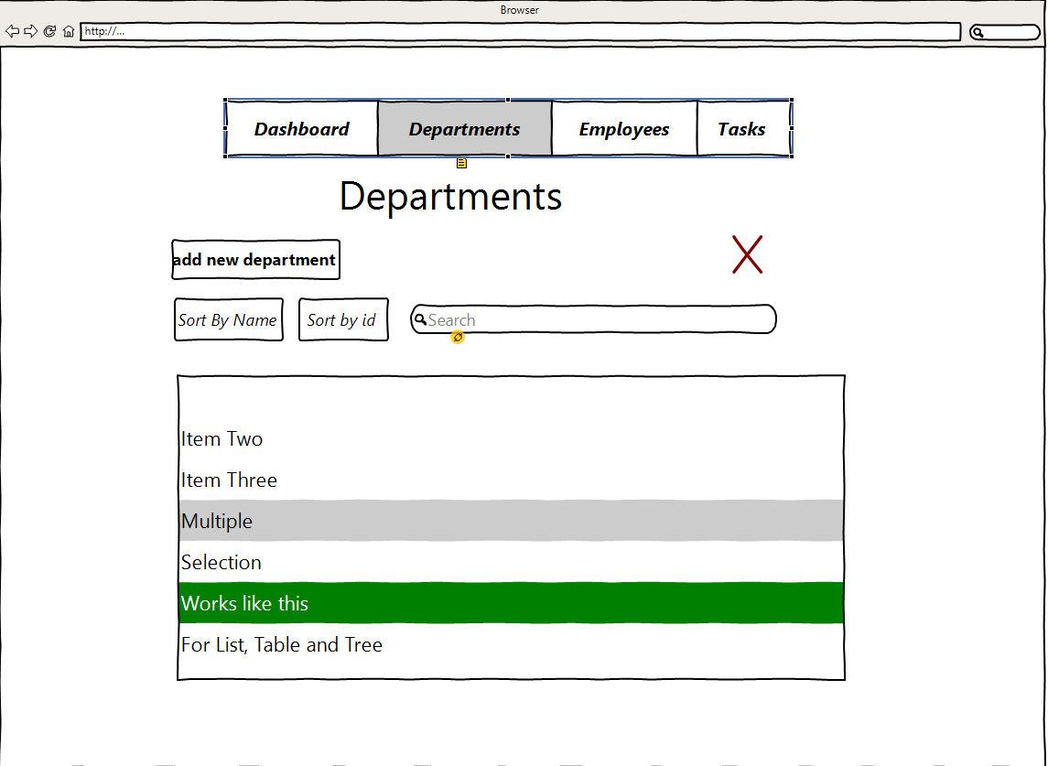

## Final Look

# 

### Dashboard

### A screenshot of a video game Description automatically generatedA screenshot of a video game Description automatically generatedDashboard

### Employees

## 

### Departments

### Adding components popup

### Tasks

### Calendar

## Sequence Diagram and Class Relationships

## A screenshot of a social media post Description automatically generatedClass Relationships